MINISTRY OF EDUCATION AND SCIENCE OF UKRAINE
UMAN NATIONAL UNIVERSITY OF HORTICULTURE

Strategy of internationalization
for 2022 – 2027

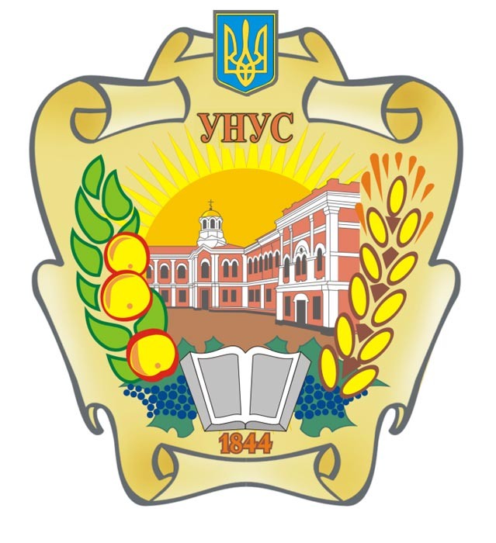

Uman
Strategy of internationalization of Uman National University of Horticulture
for 2022 - 2027

Introduction
Under modern conditions of international markets, the need to achieve high international competitiveness of higher education through its broad integration into the world scientific, educational and cultural space is due to the growing role of international education, which steadily contributes to deepening and diversifying interstate political, sociocultural, economic ties. into the global economic space. Against this background, universities around the world are stepping up competition for leadership in the global education system, which is recognized as one of the most effective levers of influence on international events. The educational potential of Uman National University of Horticulture allows him to become one of the leaders of the world educational and scientific community.
The development of the educational brand of Uman National University of Horticulture, increasing the visibility and loyalty of international organizations, foreign countries and their citizens is a factor that positively affects the integration of the University into the international educational environment and improving the quality of educational services.

Analysis of the state of international cooperation
Currently, within the framework of an international partnership, the university cooperates with Bulgaria, Germany, Slovakia, Poland, the Czech Republic, the USA, Lithuania and other countries. An important area of ​​international activity is to provide higher education students with the opportunity to study the latest agricultural technologies while undergoing foreign internships in Germany, Denmark, Poland and other countries. Programs of professional development and scientific internships in educational and scientific institutions of the partner countries are actively developing. The Department of International Cooperation operates on the basis of the University, which allows for flexibility in planning and implementing the Strategy and solving problems of internationalization of the University.
The strategy is an integral part of the University's development strategy for 2022-2027, development of scientific and educational programs.
The strategy applies to all vectors of the University's mission, ie internationalization in education and science.

Purpose and objectives of the Strategy
The strategy of internationalization of UNUH corresponds to the legal framework, namely:
− Law of Ukraine "On Higher Education";
− Law of Ukraine "On Education";
− Regulations on the procedure for exercising the right to academic mobility were approved by the Academic Council of the University, Protocol №7 of June 17, 2021;
− Charter of Uman National University, adopted by the conference of the staff on September 28, 2018, approved and registered with the Ministry of Education and Science of Ukraine on January 31, 2019 № 101;
− the relevant decision of the Academic Council of UNUH;
− other regulations in the field of higher education.
The purpose internationalization of UNUH is the formation of an effective field of structural system of international academic mobility, able to contribute to the effective implementation of statutory tasks within the full scientific and educational cycles, in the process of bringing the University to high international competitive positions.
Task:
- In-depth study and use of foreign experience in the development of education and science, including the implementation of the requirements of the Bologna Process.
- Development of educational, scientific and cultural ties of the university with foreign partners, organizations.
- Using new communication technologies to expand the geography of international cooperation.
- Update curricula and strengthen the material and technical base of the university in international educational and research projects.
- Internationalization of education, development of plans for courses on international topics and the creation of courses with a high international component.
- Increasing academic mobility: the internationalization of education in Ukraine and the EU takes place in very similar forms and directions, so foreign experience of cooperation is extremely popular.
Ways of internationalization are:
1. Establishment of a structural unit that will coordinate educational and scientific international activities, including project implementation and academic mobility.
2. Implementation on the site of up-to-date information on opportunities to participate in international programs, projects and events.
3. Promoting the participation of students, scientific and pedagogical, scientific and pedagogical workers in international programs, projects and events.
4. Support of all forms of academic mobility for scientific and pedagogical, scientific and pedagogical workers, as well as applicants for higher education and consideration in the prescribed manner of recognition of learning outcomes in foreign higher education institutions.
5. Encouraging research and teaching staff to improve the level of English and other foreign languages ​​and teaching disciplines in English and other foreign languages.
6. Encouraging administrative staff involved in international activities, scientific and scientific-pedagogical staff to increase the level of English language proficiency and preparation of English-language publications based on research results.
7. Intensification of work on the creation and implementation of joint educational and research programs with foreign universities, research institutions and organizations.
8. Involvement of teachers and scientists of foreign universities, research institutions in the educational process and research.
9. Creating conditions for attracting foreign applicants for higher education, to develop an English-language website of the University; prepare and publish on the website an English-language Information Package of educational programs.
10. Initiation of educational and scientific events (conferences, symposiums, summer and winter schools, trainings) with the participation of international partners.
11. Organization and development of international research with the participation of scientists, teachers and students, which involves active use of scientific potential of the University, attracting leading experts from foreign universities to work on topical research topics, requiring significant concentration of intellectual potential, resources, organizational and business activities.
12. Mutual transfer of creative competencies of students, graduate students, doctoral students and teachers, which allows to form a harmonious personality in the process of selecting its creative, professional, cultural, organizational and other abilities that can be identified at university, regional, national and international levels.
To ensure internationalization, the university must have:
- resource provision of the range of activities that constitute the internationalization of the university;
- mechanisms necessary to allow domestic and international students, staff and visitors to participate in internationalization activities;
- quality assurance processes of their teaching and research programs;
- a risk management and due diligence mechanism to assess potential international partnerships;
- processes of ensuring compliance of its international activities with legislation and compliance with external requirements.

Internationalization of educational activities
- development of joint training programs and training materials with foreign partners;
- creation of international student exchange programs;
- development of joint international programs of double diplomas, as well as certification programs for training;
- summarizing information on opportunities to participate in international academic programs
mobility and motivation of research and teaching staff to it;
- regular research on the effectiveness of the use of UNUH partnerships with domestic and foreign research educational institutions, research institutions and enterprises;
- establishing cooperation with foreign and domestic organizations attracting foreign students, in particular with the Ukrainian State Center for International Education of the Ministry of Education and Science of Ukraine;
- use of educational opportunities provided by foreign embassies;
- establishing a list of foreign languages ​​for which academic disciplines are taught;
- development of curricula and other regulations in English;
- implementation of training programs that provide opportunities to obtain international certificates;
- expanding the practice of involving foreign teachers in the educational process at the University.
Internationalization of scientific activity
- conducting joint international research;
- encouraging the publication of scientific papers, monographs, articles, etc. in publications included in international scientometric databases (Scopus, Web of Science, etc.)
- initiation of international research projects, attraction of international and domestic grants for them;
- conducting various international, national and regional student competitions and competitions of student research papers for students;
- active involvement of students and graduate students in research projects;
- creating conditions for foreign graduate and doctoral students to conduct joint research at the University;
- publishing jointly with foreign partners scientific monographs, other scientific publications, scientific articles in publications, including those included in the international scientometric databases Web of Science, Scopus;
- systematic holding of international conferences, forums, thematic round tables with the participation of foreign participants with a public presentation of the obtained practical results;
- active involvement of students and graduate students in the organization and holding of international events;
- development of the University Science Park.
Strategic priorities of internationalization and indicators of evaluation of the set goals:
✓ Increasing the share of full-time research and teaching staff of the university to 9% (by 2027) who participated in international academic mobility programs (lasting at least 1 month per calendar year), including the use of remote technologies, among the total number of full-time NNP .
✓ Increasing the percentage of applicants for higher education who participated in international academic mobility programs (including the use of distance technologies) to 2.5% of the total number of applicants for higher education by 2027.
✓ Annual participation in the educational process of research and teaching staff from leading universities around the world in the amount of at least 5% of the staff of the University.
✓ Increasing the number of foreign applicants for higher education to 12% (by 2027) of the total number of students
✓ Increasing the percentage of foreign applicants studying in English and EU languages ​​to 40% of the total contingent of foreign applicants.
✓ Increasing the share of classroom hours taught in English, French or German to 9% of the total number of classroom hours (until 2026/27 academic year).
✓ Ensuring the implementation of at least 3 international projects.
✓ The share of bachelors who have successfully passed the external examination in a foreign language for admission to a master's degree is at least 80%.
✓ At least 10 events a year with representatives of international organizations and embassies.

